EXPERIMENT NO. 2
AIM: Practically implement and test the cross-wired cable and straight through cable using clamping tool and network lab cable tester.
MATERIAL AND REQUIREMENTS:
- Ethernet cables (bulk cable or pre-terminated cables)
- RJ-45 connectors
- Clamping tool (crimper)
- Cable tester (with two RJ-45 connectors)
- Wire stripper and cutter
- Marker and labels
- Safety goggles (for eye protection)
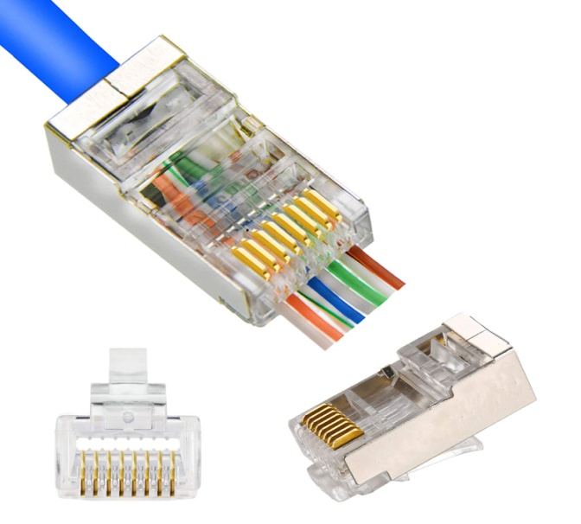
FIG: RJ-45 CONNECTOR

INTRODUCTION:
In computer networking, it's essential to understand the distinction between cross-wired (crossover) and straight-through cables. Cross-wired cables are used to connect similar devices (e.g., two computers), while straight-through cables are used to connect different devices (e.g., a computer to a switch). This practical will guide students through the process of creating and testing both cable types.
PROCEDURE:
Part 1: Cross-Wired (Crossover) Cable
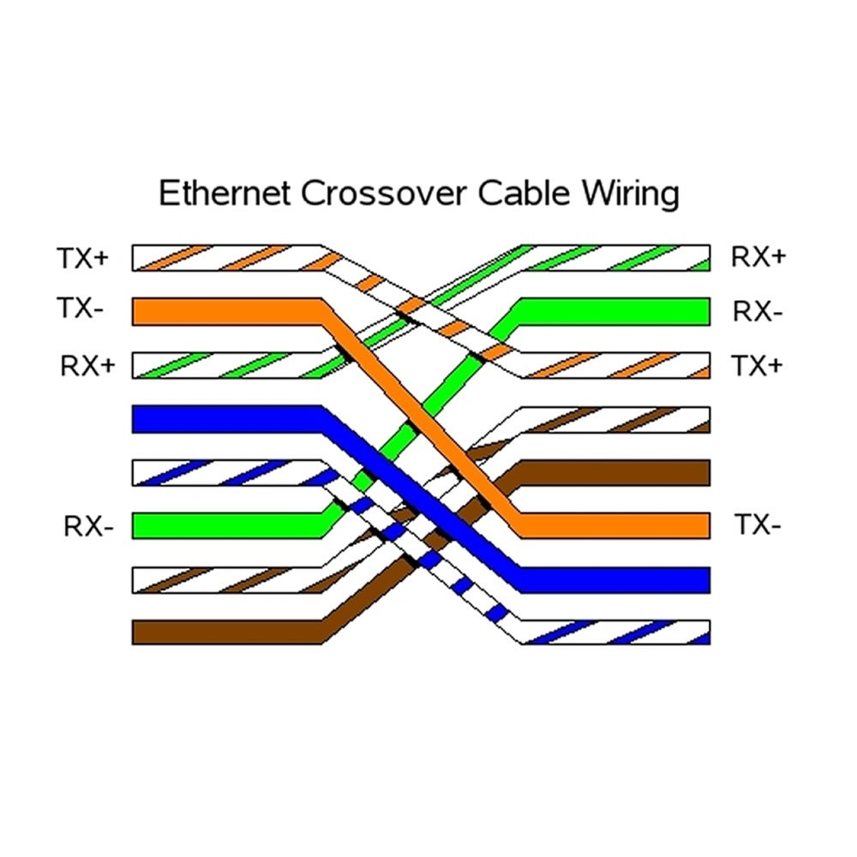
Cable Preparation:
- Start by cutting a length of Ethernet cable. Strip about 1 inch (2.5 cm) of the cable's outer insulation to expose the inner twisted pairs.
Wire Arrangement:
- Follow the T568A or T568B wiring standard for Ethernet cables.
- Cross-wire the transmit and receive wires at one end of the cable, as per the crossover cable standard (e.g., T568A at one end and T568B at the other).
Connector Termination:
- Insert the wires into an RJ-45 connector, ensuring proper alignment.
- Use a clamping tool to crimp the connector securely.
- Repeat the process for the other end, ensuring the same cross-wiring scheme.
Part 2: Straight-Through Cable
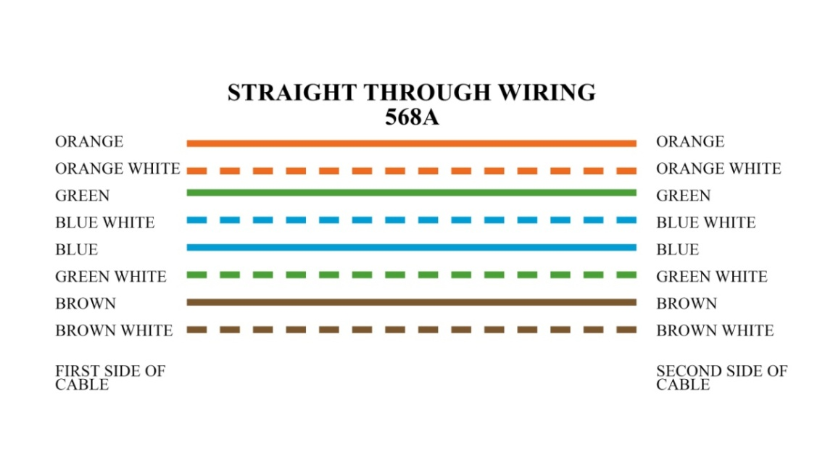
Cable Preparation:
- Cut another length of Ethernet cable. Strip about 1 inch (2.5 cm) of the cable's outer insulation to expose the inner twisted pairs.
Wire Arrangement:
- Follow either the T568A or T568B wiring standard for both ends of the cable.
Connector Termination:
- Insert the wires into an RJ-45 connector at one end, following the chosen standard.
- Use a clamping tool to crimp the connector securely.
- Repeat the process for the other end, ensuring the same wiring standard is used.

Part 3: Testing Cables
Lab Cable Tester:
- Plug one end of the created cross-wired cable into one RJ-45 connector of the lab cable tester.
- Plug the other end into the second RJ-45 connector of the tester.
- Check the tester's display for a successful connection.
- Repeat Testing for Straight-Through Cable:
- Test the straight-through cable in the same manner using the lab cable tester.
- Verify that it also shows a successful connection.

